March 27th: Cygler 2nd lecture

-In crystallography waves are described by exponential complex numbers.
-Can think of complex numbers as vectors in the complex plane with real and imaginary components instead of x and y components as in a real 2D vector.
-The addition of waves can be thought of as the addition of complex numbers.

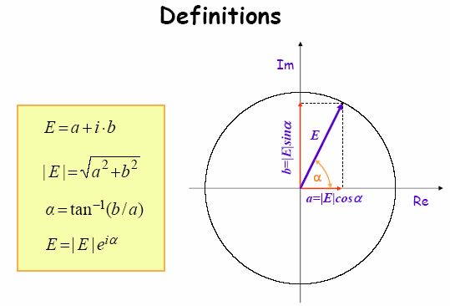

The real component of our complex number is |E|cosα
The imaginary component is |E|sinα
We use exponential complex numbers because when it comes to adding may waves together you can just add the exponents rather than dealing with cos and sin.
E= a +ib is the complex number
The length (|E| = modulus) of the vector is given by (a² +b²)^{1/2}
The angle α is the phase and is found by taking the tan⁻¹ of (b/a)
A wave has both amplitude (magnitude/modulus of the vector) and phase (angle of the vector) which are both accounted for by the expression E= |E|e^{iα}
e^{iα} represents both the real and imaginary components because e^{iα} = cosα +sinα
He went over some examples of how to apply these definitions (to the problems in the slide titled wave superposition/ interference)the next lecture.
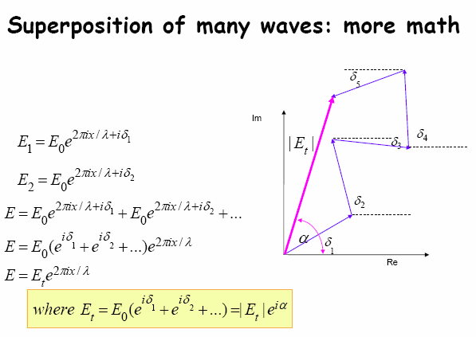
This diagram shows the addition of many waves.
α represents the total phase of the resultant wave
δ represents the phase of each individual wave.
Notice the addition of the many waves is easier in this form because you can add their phases by adding their exponents.
The other difference here is that the first wave doesn’t have a maximum at the origin (why the first term in the boxed equation isn’t 1). Remember that e^{i0}=1. A wave that has a phase of zero has a maximum at the origin.

Interference from a single slit
Parallel waves reach a wall with a slit.
You will not see a sharp image of the hole but a degradation. It will be ‘fuzzy’ around the edges. This is because at a distance from the slit (eg. a detector) the waves are interfering with each other to produce different total amplitudes.
Looking straight through the slit, the waves add up exactly in phase and the total amplitude is maximum.
At an angle to the slit, the waves do not add up perfectly in phase because they have traveled slightly different pathlengths. When waves travel the same pathlength or their pathlengths differ by exactly nλ they add in phase.

Interference from a set of Equidistant narrow slits
Again, if the pathlength of the waves that passes through the different slits differs by nλ, they add in phase and their amplitude is at a maximum. We will eventually replace these slits by the electrons in atoms. Electrons scatter light and the effect of this is the same as light passing through slits: interference occurs. When light is scattered in phase from many electrons the signal is also amplified. We use crystals because then the molecules and atoms which have electrons are equidistant and it is possible to amplify our signal. No amplification occurs from a disordered sample because the scattered waves are in turn too disordered and out of phase. We will see later that many of the scattered waves from crystals do in fact cancel each other out but some add constructively.
We are learning about slits to get a feel for wave interference and amplification
With many slits, there is interference between the slits. (Many electrons, there is interference between the electrons).
Diffraction from a grid has spacing between the slits comparable to the λ. At these distances, you get addition of the waves in phase at certain spots on the grid.
If you wanted to use a longer λ you would have to space the slits farther apart to get addition in phase. (We use x-rays because their λ is comparable to the distance between atoms (remember the proper measuring stick slide)).

If you put a particle with an electric charge in an electric field the particle is accelerated.
Electromagnetic radiation= oscillating electric and magnetic fields. If you put an electric charge (eg an electron) in an electromagnetic field it will be accelerated up and then down so that it oscillates with the same frequency as the field.
There are 2 different particles in the path of the wave: the electron and the proton (and nucleus but it is not charged). The electron oscillates much more than the proton because the proton is ~2000 times heavier. A heavier mass is much harder to accelerate and decelerate.
A charged particle that accelerates emits its own electromagnetic wave with the same frequency as that of the incoming wave.
An electron that is made to oscillate by an electromagnetic wave oscillates in the plane of that wave and emits its electromagnetic wave perpendicular to the plane of the incoming wave. You could detect this if the incoming radiation was polarized.
The incoming radiation is not polarized and so the electron emits in all directions. The lectron is a sourse of a spherical wave moving in all directions. At this point Cygler started to use the words scattered and emitted interchangeably.
The amplitude of the scattered wave must be proportional to the amplitude of the incoming radiation: Bigger radiation coming in causes bigger waves to be emitted. It is also proportional to the square of the charge and inversely proportional to the mass. The amplitude of the scattered wave is also inversely proportional to the radius (how far you are from the scattering electron). A 3D wave spreads out into space therefore the farther away we are (r) the less energy we will see.
These proportionalities are represented in E_{scat}~E_{in}e²/ (mr).
Almost all the scattering we see is due to scattering by the electrons.

Electrons move around the nucleus at ~ 2x10⁶ m/s which is much slower than the speed of light and electromagnetic radiation. (speed of light (c) = 3x10⁸ m/s). (Electromagnetic radiation of course moves at the same speed independednt of its λ).
In the time it takes an x-ray to pass through the electron hardly moves.
 remember c= λν. ν of an x-ray= c/λ = [3x10⁸ m/s / 3x10¹⁰ m] ~ 2x10¹⁸ 1/s

In one x-ray cycle an electron would move 2x10⁶ m/s / 2x10¹⁸ 1/s = 10⁻¹² m which isn’t very much compared to the total size of the atom that the electron is moving around.
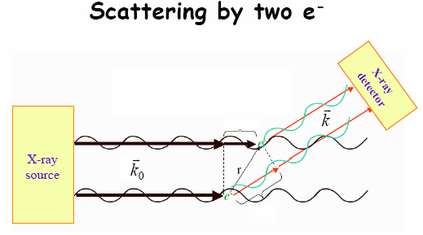
Here we see scattering by 2 electrons.
Notice it looks similar to interference through 2 slits.
k_{o} represents a vector of unit length. It carries only information about the direction of the incoming radiation. We will later replace this by the vector s which carries information about both direction and wavelength.
k also represents a vector of unit length but describes the direction of the scattered waves.
Note that all the vector symbols should have arrows on top I just didn’t put them in in the text.
The 2 scatterred waves have not traveled the same distance and may interfere with each other if their pathlength differs by a value other than nλ.
The unscatterred waves that continue through, unaffected by the electrons, are still in phase.

This is another definition: the dot product.
The dot product is no longer a vector but an amplitude.
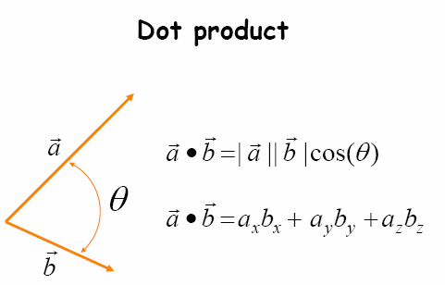
It can be expressed in terms of cos or in terms of x,y, and z.
The cross product of 2 vectors is another way to multiply vectors but the result is a vector which is perpendicular to the plane specified by the 2 multiplied vectors.
The amplitude of the wave hitting both of these electrons is the same (E_{o}).
We want to know about the amplitude of the scattered waves coming off in the direction specified by the k vector.
The difference in pathlength will cause the waves to be out of phase (ie their maxima are no longer at the same place). We need to know the difference in pathlength to be able to find the difference in their phases.

k_{o} waves are parallel
 k_{o}  r is a dot product and is a mathematical description of the length of a section of the incoming wave (where the double headed arrow is)
 k r is another dot product describing the length of the scattered wave (in this example).
The difference in pathlength between the incoming and outgoing waves is (k r) - (k_{o}  r)

 We put (k r) - (k_{o}  r) into our equation for δ (the phase) in place of Δ which represents the difference in pathlength. r can come out of this equation to give (k k_{o} / r) because r is a scalar product which we multiply by both k and k_{o.}
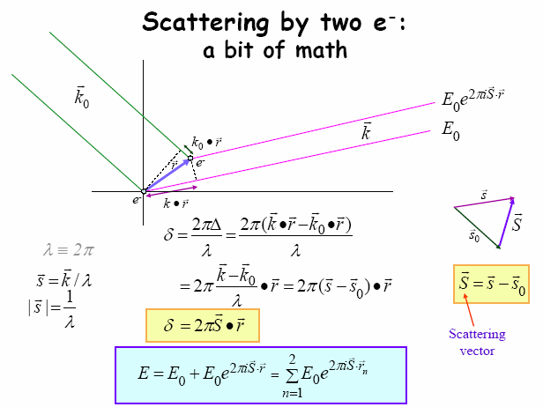
δ= 2πΔ/ λ tells us how far into the cycle of 2π you are in terms of phase.
We now introduce a new term, small vector s. (s=k/λ). It contains information about the direction of the radiation as well at its wavelength.
Capital vector S is called the scattering vector. It is the difference between the scattered radiation (k/λ) and the incoming radiation (k_{o}/λ). Next class we will see that of you rotate S so that it forms a cone, all the points that fall on the tip of this cone have the same scattering amplitude.
In the diagram above one of the electrons is at the origin (r₁ = 0). This makes the phase 0 because by convention a wave passing through the origin has a phase of 0. This makes the first term in the series E_{o}
because E_{o} e^{2πiS0} = E_{o} (e⁰=1)
The example shows scattering by 2 electrons but if we wanted to look at scattering by 3 or 4 or 100 electrons we would just add more terms to our boxed equation (n= the number of electrons you are considering).

